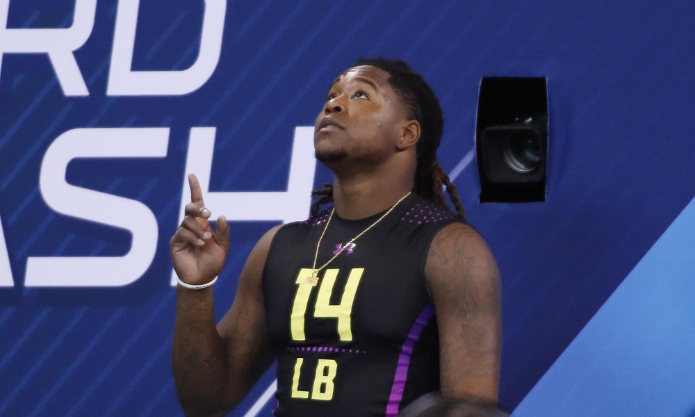
- SeahawksWire
Why Shaquem Griffin should be considered on an NFL roster.
Written by Alexis Pitchford
April 15, 2018
Shaquem Griffin, 6’1 LB from St. Petersburg (FL), should not be looked at any differently from other NFL prospects due to him only having one arm. He has managed to excel through life with this disability, and should be looked at as a whole human being, and not just a money maker. In high school, he received 21 Division 1 offers and some of those are programs from the Power 5; Boston College, Miami, Minnesota, Kentucky, and West Virginia. If big football programs considered Shaquem Griffin as a Power 5 threat, then NFL scouts should look at him with the same respect.

At UCF, he was a big contributor in revamping their football program. From having an 0-11 season, to an undefeated 13-0 season and winning the national championship in a matter of two years, he had a huge role in that transition. During his senior season, he averaged 5.69 tackles per game, 4.69 sacks per game, and recorded a career high of 12 tackles versus Auburn in the 2018 National Championship. Griffin was the 2018 Chickfila Peach Bowl Defensive MVP, 2017 ESPN All-Bowl Team, 2016 AAC Defensive Player of the Year, and 2x First-team All-AAC. But not only did he have an impact on the field, but also in his community. He received the 2018 Uplifting Athletes Rare Disease Champion award, the preseason watch list for the Wuerffel Trophy for achievements on and off the field.
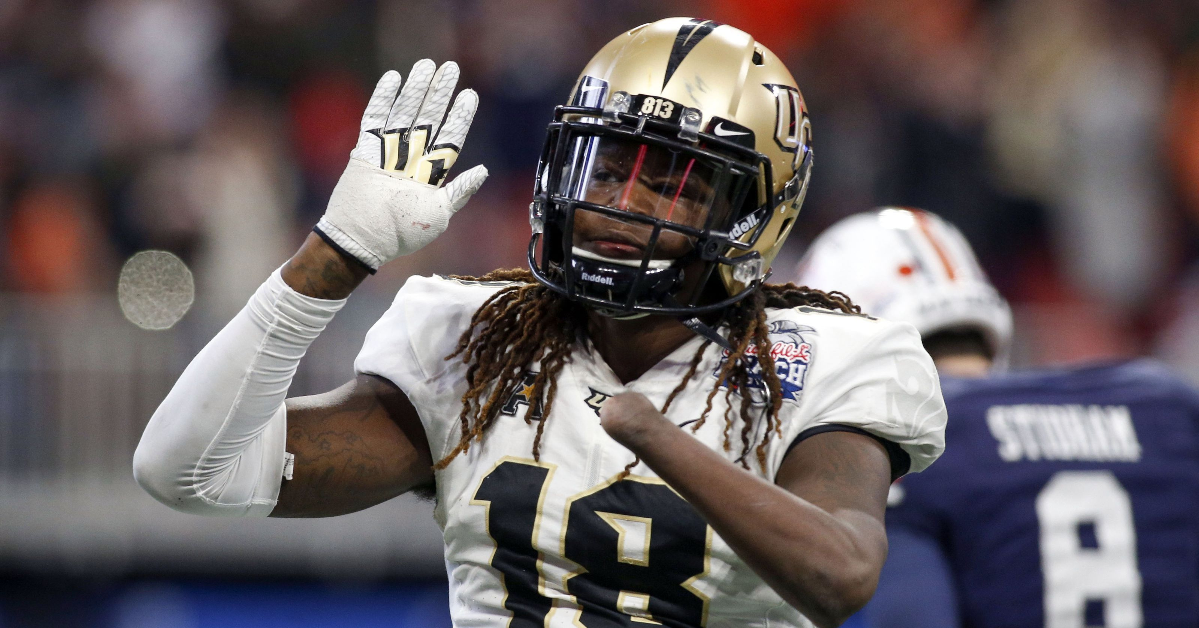
- Photo by Brett Davis of USA Today Sports
He made himself a mark at the NFL Draft. For the 40-yard dash, he recorded a 4.38s, which placed him as a top performer, ranking him 9th overall. He recorded 20 reps for the bench press which placed him 11th in linebackers. He placed 12th in linebackers in the broad jump with 117.0 inches.
Several teams in the NFL are in need of linebackers. Some teams have linebackers as a higher priority than other teams. Since Griffin is projected to be a 4th or 5th round draft pick, he’s more likely to end up with the Chicago Bears, Buffalo Bills, Green Bay Packers, Detroit Lions, and if he potentially raises his draft stock, he could end up with the Baltimore Ravens or Dallas Cowboys.

